Here’s a clear, structured breakdown of AWS Storage Types (Reading 3.1) in bullet points:

🔹 File Storage
- Organizes data in a hierarchical structure (folders/subfolders).
- Each file has metadata (name, size, creation date) and a path (e.g., computer/Application_files/Cat_photos/cats-03.png).
- Supports centralized access for multiple hosts.
- Requires file locking and integration with file system protocols.
- Common use cases:
  - Large content repositories
  - Development environments
  - User home directories

🔹 Block Storage
- Splits files into fixed-size chunks (blocks), each with its own address.
- Blocks are reassembled to form complete files when requested.
- Minimal metadata (only block address).
- Allows fast updates (change only the block containing modified data).
- Optimized for low-latency operations.
- Common use cases:
  - Databases
  - Enterprise Resource Planning (ERP) systems
  - High-performance workloads

🔹 Object Storage
- Stores data as objects in a flat structure (no hierarchy).
- Each object has a unique identifier + metadata bundled with the data.
- Updating requires rewriting the entire object (less efficient for small changes).
- Highly scalable; can store unlimited objects.
- Common use cases:
  - Large datasets
  - Unstructured files (media assets)
  - Static assets (photos, backups)

🔹 Relation to Traditional Storage Systems
- Block storage (cloud) ≈ Direct-Attached Storage (DAS) or Storage Area Network (SAN).
- File storage (cloud) ≈ Network Attached Storage (NAS).
- Object storage (cloud) = Newer model, not traditionally common on-premises.
- Cloud advantage: Flexible provisioning (create, delete, modify storage in minutes) vs. rigid, hardware-based expansion in data centers.

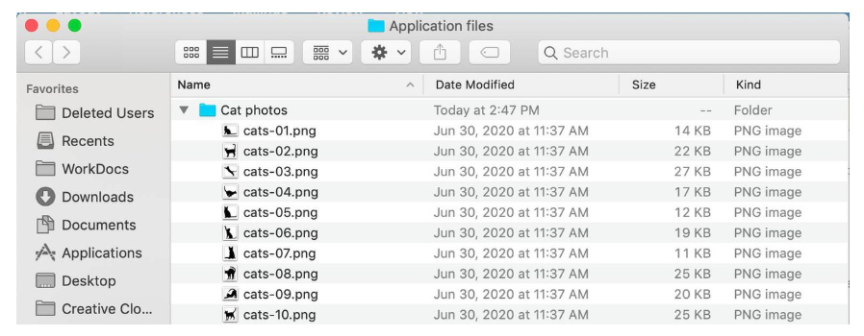

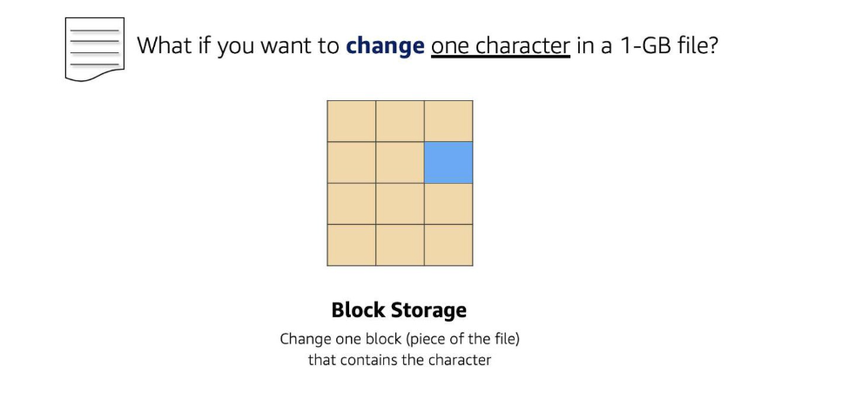
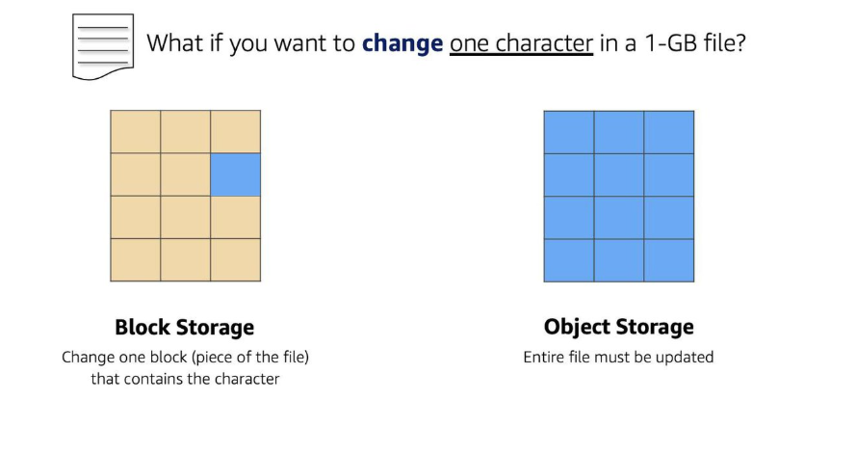

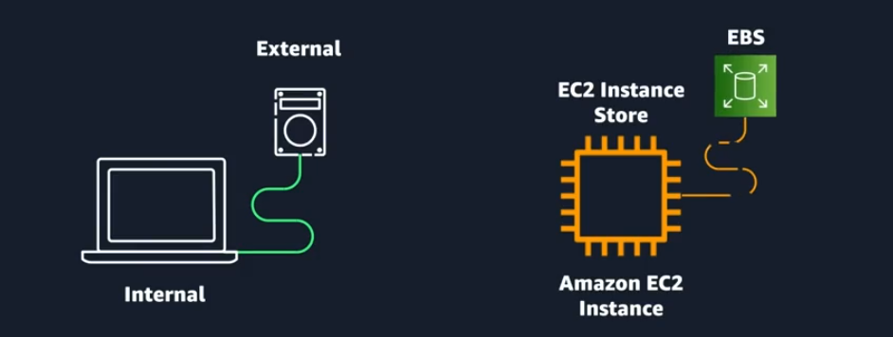

Here’s a structured breakdown of Reading 3.2: Amazon EC2 Instance Storage and Amazon Elastic Block Store (EBS) in bullet points:

🔹 Amazon EC2 Instance Store
- Provides temporary block-level storage physically attached to the host computer.
- Storage lifecycle is tied to the EC2 instance lifecycle → deleted when instance is terminated.
- Considered ephemeral storage.
- Ideal use cases:
  - Cluster-based workloads (e.g., Hadoop) with replicated data.
  - Temporary data: buffers, caches, scratch data, frequently changing content.
- Advantage: High performance due to locally attached volumes.

🔹 Amazon Elastic Block Store (EBS)
- Block-level storage device attached to EC2 instances → called EBS volumes.
- Acts like an external drive: persists independently of the instance.
- Typically one-to-one relationship with EC2 instances.
- Multi-attach feature allows some volumes to be attached to multiple EC2 instances (same Availability Zone, limited instance types).
- Volumes can be detached and reattached to other EC2 instances in the same AZ.
- Size limitations: Up to 16 TB per volume.
- Scaling options:
  - Increase volume size (up to 16 TB).
  - Attach multiple volumes to a single EC2 instance (one-to-many relationship).

🔹 Amazon EBS Use Cases
- Operating systems: Boot/root volumes (EBS-backed AMIs).
- Databases: Transactional reads/writes.
- Enterprise applications: Business-critical workloads.
- Throughput-intensive applications: Continuous reads/writes.

🔹 Amazon EBS Volume Types
Two categories: SSDs (random I/O) and HDDs (sequential I/O).
Type | Description | Use Cases | Size | Max IOPS | Max Throughput
Provisioned IOPS SSD | Highest performance, latency-sensitive | I/O-intensive NoSQL & relational DBs | 4 GB–16 TB | 64,000 | 1,000 MB/s
General Purpose SSD | Balanced price/performance | Boot volumes, dev/test, low-latency apps | 1 GB–16 TB | 16,000 | 250 MB/s
Throughput Optimized HDD | Low-cost, throughput-intensive | Big data, warehouses, log processing | 500 GB–16 TB | 500 | 500 MB/s
Cold HDD | Lowest cost, infrequent access | Colder data, fewer scans/day | 500 GB–16 TB | 250 | 250 MB/s

🔹 Benefits of Amazon EBS
- High availability: Replicated within AZ.
- Data persistence: Survives instance termination.
- Encryption: All volumes support encryption.
- Flexibility: Modify type, size, IOPS without stopping instance.
- Backups: Supports snapshots for recovery.

🔹 EBS Snapshots
- Incremental backups → only changed blocks saved.
- Stored in Amazon S3, managed automatically by AWS.
- Can create new volumes from snapshots (same or different AZ).
- Provides redundancy and disaster recovery.

Here’s a structured breakdown of Reading 3.3: Object Storage with Amazon S3 in bullet points:

🔹 What is Amazon S3?
- Standalone object storage service, not tied to compute.
- Accessible from anywhere on the web.
- Stores data in a flat structure using unique identifiers.
- Objects = file + metadata, unlimited storage capacity.
- Each object can be up to 5 TB in size.

🔹 Amazon S3 Concepts
- Buckets: Containers required to store objects.
  - Must specify bucket name (globally unique) and AWS Region.
  - Region choice ensures redundancy across multiple devices and AZs.
  - Provides 99.999999999% durability and 99.99% availability annually.
- Bucket names: Unique across all AWS accounts; released if bucket is deleted.
- Object identifiers:
  - Formed as a URL → includes bucket name, service name, and object key.
  - Example: http://doc.s3.amazonaws.com/2006-03-01/AmazonS3.html.
- Folders in buckets: Only logical/visual organization; backend remains flat.

🔹 Amazon S3 Use Cases
- Backup & storage: Highly redundant; EBS snapshots stored in S3.
- Media hosting: Unlimited objects, large file support (up to 5 TB).
- Software delivery: Host applications for customer downloads.
- Data lakes: Virtually unlimited scalability, pay-as-you-go model.
- Static websites: Buckets can host HTML, CSS, and client-side scripts.
- Static content storage: Ideal for photos, videos, logs, and other assets.

This section highlights how S3 differs from EBS:
- EBS = block storage tied to EC2.
- S3 = object storage, independent of compute, globally accessible, highly durable.
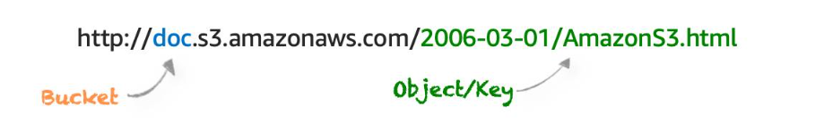
Here’s a structured breakdown of Choosing the Right Connectivity Option for Amazon S3 Resources in bullet points:

🔹 Default Privacy
- All S3 resources (buckets, folders, objects) are private by default.
- Only the creator AWS account can access them initially.
- You can make resources public, but this exposes them to everyone on the internet.
- Best practice: Use granular permissions instead of all-or-nothing access.

🔹 IAM Policies
- Define actions users, groups, or roles can perform across AWS services.
- Centralized management → policies apply to multiple buckets and services.
- Best for private buckets when:
  - You have many buckets with different permission requirements.
  - You want all policies managed in one location.

🔹 S3 Bucket Policies
- Written in JSON, similar to IAM policies.
- Attached only to buckets (not folders or objects).
- Apply to all objects in the bucket.
- Best for:
  - Cross-account access without IAM roles.
  - Situations where IAM policies hit size limits.
- Example: Allowing public read access with "Effect": "Allow" and "Action": ["s3:GetObject"].

🔹 Encryption in S3
- In transit: SSL or client-side encryption.
- At rest:
  - Server-side encryption (SSE): S3 encrypts before saving, decrypts on download.
  - Client-side encryption: You encrypt before upload; you manage keys/tools.

🔹 Versioning
- Prevents accidental overwrites or deletions.
- Each object gets a unique version ID.
- Deleting an object adds a delete marker (can be removed to restore).
- Overwriting creates a new version; old versions remain accessible.
- Helps recover from accidental deletions, overwrites, or application failures.

🔹 Versioning States
- Unversioned (default): No versions maintained.
- Versioning-enabled: All objects get version IDs.
- Versioning-suspended: New objects won’t have versions, but existing ones retain theirs.
- Cost consideration: Storage charges apply for all versions; delete unused versions to reduce costs.

This section emphasizes security + resilience in S3:
- IAM policies → centralized, multi-service control.
- Bucket policies → bucket-specific, cross-account access.
- Encryption → protects data in transit and at rest.
- Versioning → safeguards against accidental data loss.

Here’s a structured breakdown of Amazon S3 Storage Classes & Lifecycle Management in bullet points:

🔹 Amazon S3 Storage Classes
- S3 Standard
  - Default storage class.
  - General-purpose: cloud apps, dynamic websites, content distribution, mobile/gaming apps, big data analytics.
- S3 Intelligent-Tiering
  - For unknown/changing access patterns.
  - Automatically moves objects between frequent and infrequent access tiers based on usage.
- S3 Standard-Infrequent Access (S3 Standard-IA)
  - For less frequently accessed data but requires rapid access when needed.
  - Lower storage cost, retrieval fee applies.
  - Ideal for backups, disaster recovery files.
- S3 One Zone-Infrequent Access (S3 One Zone-IA)
  - Stores data in one Availability Zone (vs. three in other classes).
  - Costs ~20% less than Standard-IA.
  - Best for secondary backups or easily re-creatable data.
- S3 Glacier Instant Retrieval
  - Lowest-cost archive storage for rarely accessed data.
  - Retrieval in milliseconds.
- S3 Glacier Flexible Retrieval
  - ~10% lower cost than Glacier Instant Retrieval.
  - For archive data accessed 1–2 times per year.
  - Retrieval is asynchronous.
- S3 Glacier Deep Archive
  - Lowest-cost storage class.
  - Long-term retention (7–10+ years).
  - Designed for regulatory compliance (finance, healthcare, public sector).
- S3 Outposts
  - Provides object storage on-premises via AWS Outposts.

🔹 Automate Tier Transitions with Lifecycle Management
- Lifecycle policies automate storage transitions and deletions.
- Transition actions: Move objects to another storage class after a set time.
  - Example: Move logs to S3 Standard-IA after 30 days.
  - Archive objects to Glacier after 1 year.
- Expiration actions: Permanently delete objects after a defined period.

🔹 Lifecycle Management Use Cases
- Periodic logs: Needed short-term, then deleted.
- Data with changing access frequency: Frequently accessed initially, then archived later.
- Regulatory compliance: Archive data for required retention periods, then delete.

This section highlights how S3 storage classes balance cost vs. access speed and how lifecycle policies automate transitions to optimize storage costs.

Here’s a structured breakdown of Reading 3.4: Choosing the Right Storage Service in bullet points:

🔹 Amazon EC2 Instance Store
- Ephemeral block storage tied to the lifecycle of the EC2 instance.
- Exists on the same physical server as the instance.
- Cannot be detached → acts like a built-in drive.
- Best for temporary data: buffers, caches, scratch data.
- Not suitable for persistent storage.
- If persistence is needed → use Amazon EBS.

🔹 Amazon Elastic Block Store (EBS)
- Persistent block storage that survives instance stops/terminations.
- Two volume types:
  - SSD-backed volumes → performance depends on IOPS, ideal for databases & boot volumes.
  - HDD-backed volumes → performance depends on MB/s, ideal for big data, warehouses, log processing.
- Key features:
  - Block storage.
  - Provisioned storage (pay for what you allocate).
  - Replicated across servers in a single AZ.
  - Most volumes attach to one EC2 instance at a time.

🔹 Amazon S3
- Object storage solution, independent of compute.
- Best for static content: web files, media, backups, archives, analytics data.
- Can host static websites with custom domains.
- Key features:
  - Pay for what you use (no pre-provisioning).
  - Replicates objects across multiple AZs in a Region.
  - Unlimited scalability.

🔹 Amazon Elastic File System (EFS) & Amazon FSx
- Provide file storage that can be mounted on multiple EC2 instances.
- Amazon EFS: Fully managed NFS file system.
- Amazon FSx for Windows File Server: Fully managed Windows file server, supports SMB protocol.
- Amazon FSx for Lustre: Fully managed Lustre file system, integrates with S3.
- Key features:
  - File storage.
  - Pay for what you use (no pre-provisioning).
  - Supports multi-instance mounting.

🔹 Quick Decision Guide
- Temporary, fast-changing data → EC2 Instance Store.
- Persistent, frequently changing data → Amazon EBS.
- Static or infrequently changing data → Amazon S3.
- Shared file storage across multiple EC2s → Amazon EFS or FSx.

This recap ties everything together: Instance Store = ephemeral, EBS = persistent block, S3 = scalable object, EFS/FSx = shared file storage.

Here’s a structured breakdown of Reading 3.5: Explore Databases on AWS in bullet points:

🔹 History of Enterprise Databases
- Earlier, businesses had few database options → often chose one vendor for all applications.
- Since the 1970s, relational databases became the dominant choice.
- Decisions were often made before fully understanding use cases.

🔹 Relational Databases
- Organize data into tables (rows & columns).
- Rows (records): represent entries.
- Columns (attributes): describe properties of entries.
- Relationships: common columns link tables (logical schema).
- Schema is fixed → requires upfront modeling, harder to change later.

🔹 Relational Database Management Systems (RDBMS)
- Software to create, update, and administer relational databases.
- Examples: MySQL, PostgreSQL, Oracle, SQL Server, Amazon Aurora.
- Use SQL queries for data operations.
  - Example: SELECT * FROM table_name.
- SQL enables joins → combine data across tables for insights.

🔹 Benefits of Relational Databases
- Joins: Understand relationships between data.
- Reduced redundancy: Reference data instead of duplicating.
- Familiarity: Widely used since 1970s → professionals have experience.
- Accuracy: Adheres to ACID principles (atomicity, consistency, isolation, durability).

🔹 Use Cases
- Applications with stable schemas.
- Lift-and-shift applications (migrate on-premises apps to cloud with minimal changes).
- Enterprise workloads requiring ACID compliance:
  - ERP (Enterprise Resource Planning).
  - CRM (Customer Relationship Management).
  - Commerce & financial applications.

🔹 Managed vs. Unmanaged Databases on AWS
- On-Premises Database:
  - Full responsibility → data center, hardware, host machine, database, queries, customer data.
  - Maximum control, maximum responsibility.
- Unmanaged Database (on Amazon EC2):
  - AWS manages hardware + infrastructure + OS.
  - Customer manages EC2 instance, database, queries, customer data.
  - Tradeoff: AWS handles infrastructure, customer retains control of database management.
- Managed Database (AWS services like RDS, Aurora):
  - AWS manages instance + database setup, high availability, scalability, patching, backups.
  - Customer manages query optimization, tuning, data security.
  - Tradeoff: Maximum convenience, least control.

This section highlights the evolution from traditional relational databases to AWS-managed services, showing how businesses can choose between control vs. convenience depending on their needs.
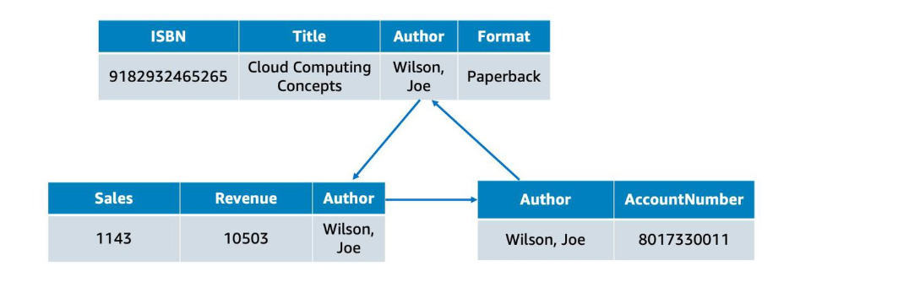

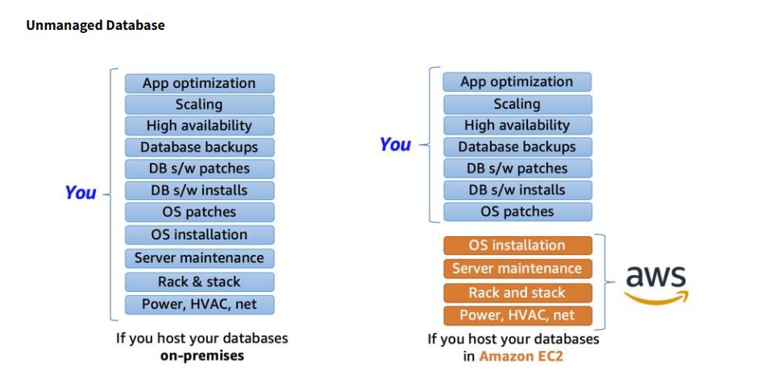
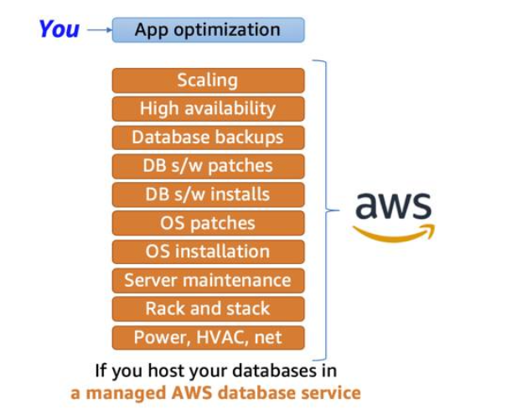

Here’s a structured breakdown of Reading 3.6: Amazon Relational Database Service (RDS) in bullet points:

🔹 What is Amazon RDS?
- Fully managed service for relational databases in the cloud.
- Removes operational burden: provisioning, patching, scaling, restoring.
- Lets you focus on application logic instead of infrastructure.
- Supports multiple engines:
  - Commercial: Oracle, SQL Server.
  - Open Source: MySQL, PostgreSQL, MariaDB.
  - Cloud Native: Amazon Aurora (MySQL/PostgreSQL-compatible, faster, more durable).

🔹 DB Instances
- Compute portion of RDS → runs the database engine.
- A DB instance can contain multiple databases with the same engine.
- Managed via RDS console (not EC2 console).
- Instance families:
  - Standard: General-purpose.
  - Memory Optimized: For memory-intensive workloads.
  - Burstable Performance: Baseline CPU with burst capability.
- Storage layer uses Amazon EBS volumes:
  - General Purpose SSD.
  - Provisioned IOPS SSD.
  - Magnetic (legacy, not recommended).

🔹 Networking & Security
- DB instances live inside an Amazon VPC.
- Placed in DB subnet groups (private subnets across AZs).
- Access restricted via network ACLs and security groups.
- IAM policies control employee access to actions/resources.

🔹 Backups
- Automatic backups:
  - Enabled by default.
  - Backs up entire DB instance + transaction logs.
  - Retention: 0–35 days (0 disables backups).
  - Supports point-in-time recovery.
- Manual snapshots:
  - User-initiated, retained until deleted.
  - Useful for long-term compliance (e.g., 1-year retention).
  - Restoring creates a new DB instance.
- Best practice: Use both automatic backups + manual snapshots.

🔹 Multi-AZ Deployment
- Creates a redundant standby copy in another Availability Zone.
- Primary DB handles queries; standby is synchronously replicated.
- Automatic failover:
  - If primary fails, standby is promoted.
  - DNS automatically redirects queries to new primary.
- Ensures high availability & resilience.
- Standby is not active for queries, only for failover.

🔹 Key Benefits of Amazon RDS
- Simplifies database management.
- Provides scalability, durability, and availability.
- Supports multiple engines (commercial, open-source, cloud-native).
- Offers automated backups, snapshots, and Multi-AZ redundancy.
- Integrates with VPC, IAM, and security groups for layered protection.

This section highlights how Amazon RDS balances convenience and control: you offload infrastructure tasks to AWS while retaining responsibility for query optimization and data security.
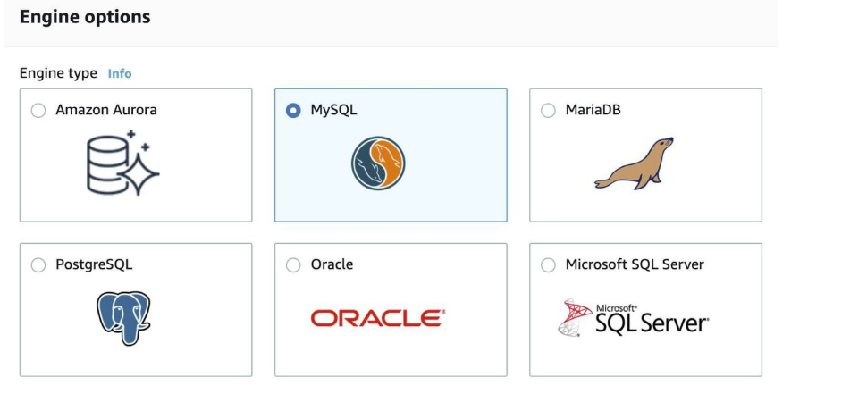
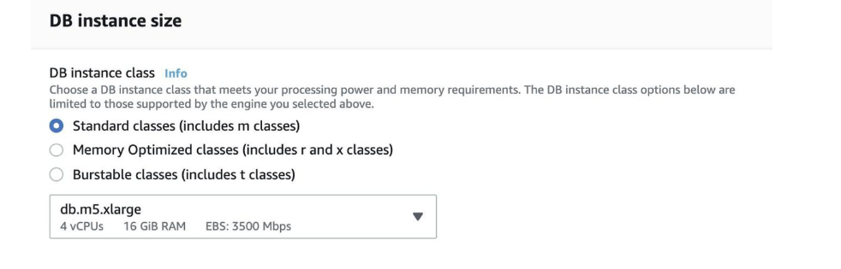
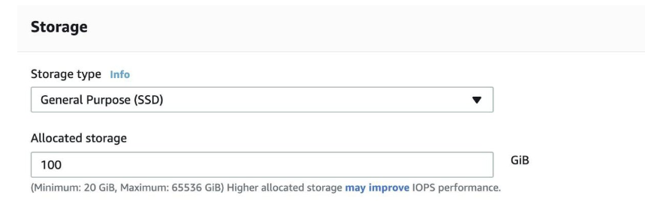
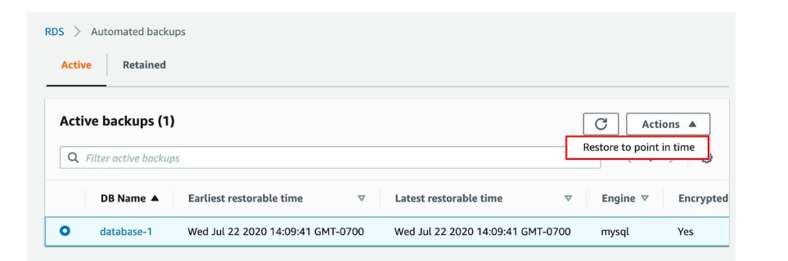
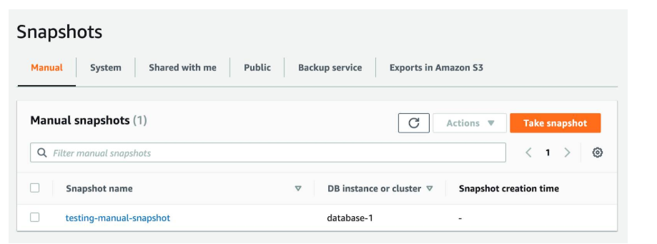

Here’s a structured breakdown of Reading 3.8: Introduction to Amazon DynamoDB in bullet points:

🔹 What is Amazon DynamoDB?
- Fully managed NoSQL database service.
- Provides fast, predictable performance with seamless scalability.
- Offloads administrative tasks: hardware provisioning, setup/configuration, replication, patching, cluster scaling.
- Can store/retrieve any amount of data and handle any level of request traffic.
- Throughput capacity can be scaled up or down without downtime.
- Data and traffic automatically spread across servers for performance.
- Data stored on SSDs and replicated across multiple Availability Zones → high availability & durability.

🔹 Core Components
- Tables: Collections of items (e.g., People table, Cars table).
- Items: Individual records within a table (similar to rows/tuples).
  - Example: Each item in People table = one person.
- Attributes: Fundamental data elements (similar to columns/fields).
  - Example: PersonID, LastName, FirstName in People table.
- Primary keys: Uniquely identify items in a table.
- Secondary indexes: Provide flexible querying options.

🔹 Security
- Supports encryption at rest → protects sensitive data without operational complexity.
- Integrated with AWS security features for compliance and data protection.

🔹 Key Benefits
- NoSQL flexibility → schema-less design, supports diverse data models.
- Automatic scaling → adjusts to workload demands.
- High durability & availability → replication across AZs.
- Performance consistency → SSD-backed storage.
- Ease of management → AWS handles infrastructure, replication, and scaling.

This section highlights how DynamoDB differs from RDS:
- RDS = relational, schema-based, SQL-driven.
- DynamoDB = NoSQL, schema-less, highly scalable, managed for performance.
Here’s a structured breakdown of Reading 3.9: Choose the Right AWS Database Service in bullet points:

🔹 AWS Database Portfolio
- Relational Databases
  - Use cases: Traditional apps, ERP, CRM, e-commerce.
  - Services: Amazon RDS, Amazon Aurora, Amazon Redshift.
- Key-Value Databases
  - Use cases: High-traffic web apps, e-commerce systems, gaming apps.
  - Service: Amazon DynamoDB.
- In-Memory Databases
  - Use cases: Caching, session management, gaming leaderboards, geospatial apps.
  - Services: Amazon ElastiCache for Memcached, Amazon ElastiCache for Redis.
- Document Databases
  - Use cases: Content management, catalogs, user profiles.
  - Service: Amazon DocumentDB (MongoDB-compatible).
- Wide Column Databases
  - Use cases: Industrial-scale apps (equipment maintenance, fleet management, route optimization).
  - Service: Amazon Keyspaces (for Apache Cassandra).
- Graph Databases
  - Use cases: Fraud detection, social networking, recommendation engines.
  - Service: Amazon Neptune.
- Time Series Databases
  - Use cases: IoT apps, DevOps monitoring, industrial telemetry.
  - Service: Amazon Timestream.
- Ledger Databases
  - Use cases: Systems of record, supply chain, registrations, banking transactions.
  - Service: Amazon QLDB.

🔹 Breaking Up Applications and Databases
- Modern applications often use multiple purpose-built databases instead of one monolithic database.
- Each service supports a specific workload requirement (functionality, performance, scale).
- Strategy: Complementary database approach → choose the right database for each microservice.
- Benefits: Optimized performance, scalability, and cost-efficiency.

This section emphasizes that AWS offers a diverse database ecosystem, moving away from the one-size-fits-all model to a purpose-built database strategy.
Database Type | Use Cases | AWS Service
Relational | Traditional applications, ERP, CRM, e-commerce | Amazon RDS, Amazon Aurora, Amazon Redshift
Key-value | High-traffic web apps, e-commerce systems, gaming applications | Amazon DynamoDB
In-memory | Caching, session management, gaming leaderboards, geospatial applications | Amazon ElastiCache for Memcached, Amazon ElastiCache for Redis
Document | Content management, catalogs, user profiles | Amazon DocumentDB (with MongoDB compatibility)
Wide column | High-scale industrial apps for equipment maintenance, fleet management, and route optimization | Amazon Keyspaces (for Apache Cassandra)
Graph | Fraud detection, social networking, recommendation engines | Amazon Neptune
Time series | IoT applications, DevOps, industrial telemetry | Amazon Timestream
Ledger | Systems of record, supply chain, registrations, banking transactions | Amazon QLDB

